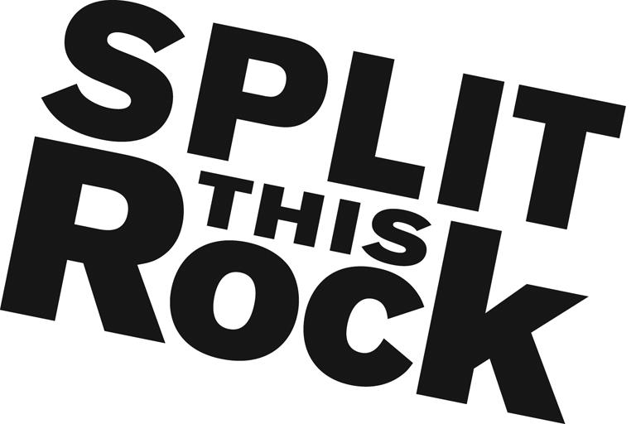

Split This Rock Youth Programs Internship

Organizational Summary

Split This Rock is a non-profit organization that brings poetry to the center of public life and fosters a national network of socially engaged poets. From our home in the nation's capital we celebrate poetic diversity and the transformative power of the imagination. All of Split This Rock's programs are designed to integrate poetry of provocation and witness into public life and to support the poets who write and perform this critical work.

We also have a robust youth program that has grown to include the DC Youth Slam Team, school poetry clubs, creative writing and performance workshops, open mics, and social justice campaigns at intersection of poetry and social change. Split This Rock teaches, supports and engages young poets in the DMV area by providing exceptional opportunities for students to learn and practice the skills and techniques of performance poetry. Through our ongoing series of public youth open mics, team performances, workshop, and slam regional and national poetry competitions, we create safe spaces for artistic, personal, and community growth.

We’re a small but passionate staff housed at the Institute for Policy Studies, the nation’s oldest progressive think tank, located a few blocks from the White House in downtown DC.

Position Description

This un-paid position combines opportunities to apply and expand your skills in youth-focused program development, event planning, mentoring, marketing, and communications. You will have the opportunity to contribute in significant and meaningful ways to the continued growth of our youth programs. Working with Split This Rock’s youth programs staff, specific intern responsibilities include:

- Assist with planning, implementation, and outreach for The World & Me poetry contest, a city-wide competition for young poets culminating in a public celebration and reading with the finalists. This includes classroom visits and judging students’ poems.
- Provide organizing and fundraising support to the DC Youth Slam Team, including help with grant writing and obtaining new sponsorships.
- Assist with marketing and publicity (including social media) for ongoing youth program events (youth poetry slams, open mics and special events), especially our Louder Than A Bomb-DMV Teen Poetry Slam Festival
- Attend writing workshops and youth poetry events, and help to run the door, sell tickets, answer questions, etc.
- Assist with other office tasks as needed--filing, office organization, research, and the day-to-day duties of running a small nonprofit

Qualifications
We are looking for interns who are:
- Extremely organized with attention to detail and follow through
- Excellent writing and communications skills
- Passionate and committed to social change
- Knowledge of poetry
- Ability to manage multiple tasks on self-determined schedule
- Flexible and good-natured
- Comfortable in cross-cultural settings
- Solid computer skills, including Microsoft Office Suite
- College or graduate students, or recent grads

This is an exciting opportunity to work with a growing literary arts organization that is unique in the field, working directly with DMV youth, while getting to know the local poetry and arts community. We’re looking for an intern who can commit to working 15-20 hours per week (flexible schedule) for a minimum of 10 weeks (ideally longer).

To apply, please send a resume, cover letter outlining your interest in Split This Rock and why you would be a good fit for this position, and a brief writing sample (no more than two pages) to Chelsea Iorlano at chelsea@splitthisrock.org. We look forward to hearing from you!

