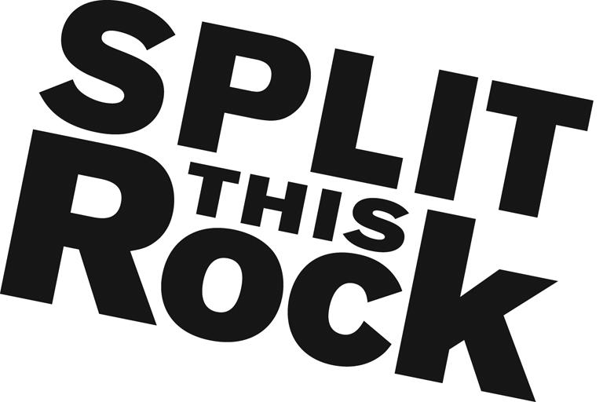

Split This Rock
Freedom Plow Award for Poetry & Activism Internship

Organizational Summary
Split This Rock is a non-profit organization that brings poetry to the center of public life and fosters a national network of socially engaged poets. From our home in the nation's capital we celebrate poetic diversity and the transformative power of the imagination. All of Split This Rock's programs are designed to integrate poetry of provocation and witness into public life and to support the poets who write and perform this critical work.

Our cornerstone program is a biennial national festival celebrating poetry and activism, held in Washington, DC. We also have a robust youth program, organize social justice campaigns, present readings and workshops, and sponsor year-round local and national programming at the intersection of poetry and social change. We’re a small but passionate staff housed at the Institute for Policy Studies, the nation’s oldest progressive think tank, located a few blocks from the White House in downtown DC.

Position Description
The Freedom Plow Award for Poetry & Activism Internship is a 6-month, part-time, unpaid internship that allows an intern to work directly with a growing literary arts organization, receiving hands-on exposure to the inner-workings of a social justice non-profit. The internship offers a unique opportunity to be immersed, simultaneously, in the rich literary and activism scenes of DC. It combines opportunities to apply and expand skills in program development, event planning, marketing, communications, and non-profit development. The intern will have the opportunity to contribute in significant and meaningful ways to the continued growth of a small mission-driven non-profit organization. The internship begins in October and ends in March or April.

The Freedom Plow Award for Poetry & Activism Intern will play a key role in developing, planning and organizing all aspects of the second biennial Freedom Plow Award for Poetry & Activism. The award recognizes and honors a poet who is doing innovative and transformative work at the intersection of poetry and social change. The intern will work directly with the Executive Director on developing, planning, and organizing all aspects of the award, from soliciting nominations to organizing the gala award ceremony.

Specifically, the intern will work with Split This Rock’s staff to:
- Coordinate award logistics
  - Assess the list of nominators and recruit additional, as needed
  - Solicit nominations
  - Assist in assembling a prominent national jury
  - Provide staff support to the jury process
  - Coordinate with poet activists around the country
  - Plan an award ceremony and reception
- Participate in marketing and publicity for the award, including social media and press outreach

Additionally, the intern will:
- Assist with other office tasks as needed--office organization, research, and the day-to-day duties of running a small nonprofit

Qualifications
We are looking for interns who are/have:
- Extremely organized with attention to detail and follow through
- Excellent writing and communications skills
- Passionate and committed to social change
- Some knowledge and love of poetry
- Able to manage multiple tasks on self-determined schedule
- Flexible and good-natured
- Comfortable in cross-cultural settings
- Solid computer skills, including Microsoft Office Suite
- College or graduate students, or recent grads

This is an exciting opportunity to work with a growing literary arts organization that is unique in the field, while getting to know the vibrant Washington DC poetry and arts community. We’re looking for an intern who can commit to working 15 hours per week (flexible schedule) from October through March or April.

To apply, please send: 1) resume, 2) cover letter clearly outlining your interest in Split This Rock, why you would be a good fit for this position and what you hope to gain from this internship, 3) a brief non-poetry writing sample (no more than two pages), and 4) names/contact info for two professional or academic references to Camisha Jones at camisha@splitthisrock.org. We look forward to hearing from you!

