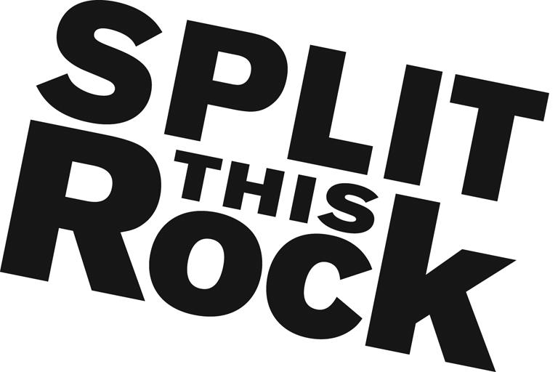

Programs Support Internship

Organizational Summary
Split This Rock is a non-profit organization that brings poetry to the center of public life and fosters a national network of socially engaged poets. From our home in the nation's capital we celebrate poetic diversity and the transformative power of the imagination. All of Split This Rock's programs are designed to integrate poetry of provocation and witness into public life and to support the poets who write and perform this critical work.

Our cornerstone program is a biennial national festival celebrating poetry and activism, held in Washington, DC. The last festival took place April 19-21, 2018. Over the course of the three days writers and activists from all over the country gather to participate in panels, workshops, and group readings. Each night brings featured readings by some of the country’s most essential voices. Featuring at the 2018 festival were: Sharon Olds, Solomoz Sharif, Sonia Sanchez, Elizabeth Acevedo, Paul Tran and more.
We also have a robust youth program, organize social justice campaigns, present readings and workshops, and sponsor year-round local and national programming at the intersection of poetry and social change. We’re a small but passionate staff housed at the Institute for Policy Studies, the nation’s oldest progressive think tank, located a few blocks from the White House in downtown DC.

We offer ongoing unpaid internship opportunities in the areas of: fundraising/development, event planning, youth programming, publicity/marketing, outreach, media relations, website development, accessibility planning, documentation/archival development, graphic design and administrative support.

Position Description
This un-paid position (travel stipend potentially available upon request) combines opportunities to apply and expand your skills in event planning and execution, marketing, and communications. You will have the opportunity to contribute in significant and meaningful ways to the continued growth of a small mission-driven non-profit organization and its cornerstone program.
The Programs Assistant intern will assist with preparation for various events, including fundraising house parties, writing workshops, monthly open mics, Split This Rock's 2020 poetry festival and other special events. Duties would include helping to create printed materials, researching potential venues, gathering supplies, outreach related to preparing the poetry festival and staffing events. Additionally, the intern, as needed, will assist with administrative and publicity duties, such as postings to social media, database management, website management and preparing emails to our network.

Qualifications
We are looking for interns who are:
- Experience in event planning
- Extremely organized with attention to detail and follow through
- Excellent writing and communications skills
- Passionate and committed to social change
- Have some knowledge and love of poetry
- Able to manage multiple tasks on self-determined schedule
- Flexible and good-natured
- Comfortable in cross-cultural settings
- Solid computer skills, including familiarity (with Microsoft Office Suite, ConstantContact, and GiftWorks is a plus but not required.
- College or graduate students, or recent grads

This is an exciting opportunity to work with a growing literary arts organization that is unique in the field, while getting to know the local poetry and arts community. We’re looking for an intern who can commit to working 10-15 hours per week (flexible schedule) for a minimum of 3-4 months (ideally longer).

To apply, please send a resume, a thoughtful cover letter outlining your interest in Split This Rock and why you would be a good fit for this position, and a brief prose writing sample (no more than two pages - no poetry please) to Emma Bartley at emma@splitthisrock.org. We are accepting applications on a rolling basis. We look forward to hearing from you!

