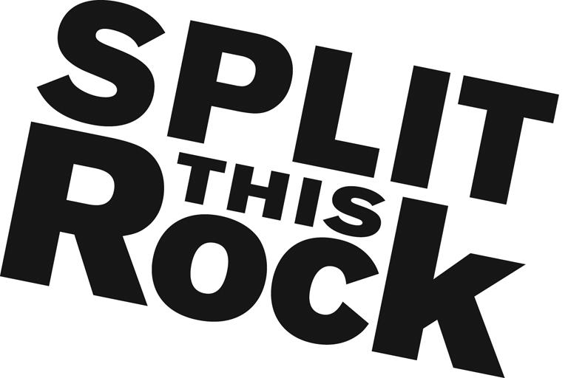

Split This Rock Poetry Database Internship

Organizational Summary
Split This Rock is a non-profit organization that brings poetry to the center of public life and fosters a national network of socially engaged poets. Split This Rock cultivates, teaches, and celebrates poetry that bears witness to injustice and provokes social change. From our home in the nation's capital we celebrate poetic diversity and the transformative power of the imagination. All of Split This Rock's programs are designed to integrate poetry of provocation and witness into public life and to support the poets who write and perform this critical work.

Our cornerstone program is a biennial national festival celebrating poetry and activism, held in Washington, DC. We also have a robust youth program, organize social justice campaigns, present readings and workshops, and sponsor year-round local and national programming at the intersection of poetry and social change. We’re a small but passionate staff housed at the Institute for Policy Studies, the nation’s oldest progressive think tank, located a few blocks from the White House in downtown DC.

Position Description
This un-paid position (travel stipend potentially available upon request) combines opportunities to apply and expand your skills in marketing, communications, and outreach. You will have the opportunity to contribute in significant and meaningful ways to the continued growth of a small mission-driven non-profit organization.

The Poetry Database Intern will be responsible for publicizing and promoting The Quarry as a community resource and tool. The intern will oversee outreach efforts to activist groups, educational institutions, community organizations and others to introduce them to The Quarry. This role includes, but is not limited to, brainstorming ways to engage the public in using The Quarry and promotion of the database in general, social media campaigns, development of resources connecting poems in The Quarry to relevant social issues, presentations to local groups, writing blog posts. As needed, the intern may also assist with maintenance of The Quarry itself, administrative tasks, and other duties as assigned.

Qualifications
We are seeking an intern with the following qualifications:
- Attention to detail
- Extremely organized with reliable follow through
- Excellent writing and communications skills
- Able to manage multiple tasks on self-determined schedule
- Passionate and committed to social change
- Some knowledge and love of poetry
- Flexible and good-natured
- Comfortable in cross-cultural settings
- Solid computer skills including familiarity with Microsoft Office Suite and social media. Experience with Constant Contact, Blogger, and website content management a plus but not required.
- College students, graduate students and recent graduates preferred though individuals with comparable experience are welcomed to apply

This is an exciting opportunity to work with a growing literary arts organization that is unique in the field, while getting to know the local poetry and arts community. We’re looking for an intern who can commit to working 10-15 hours per week (flexible schedule) for a minimum of 3-4 months (ideally longer).

To apply, please send a resume, a thoughtful cover letter outlining your interest in Split This Rock and why you would be a good fit for this position, and a brief prose writing sample (no more than two pages - no poetry please) to Tiana Trutna at tiana@splitthisrock.org. We are accepting applications on a rolling basis. We look forward to hearing from you!

