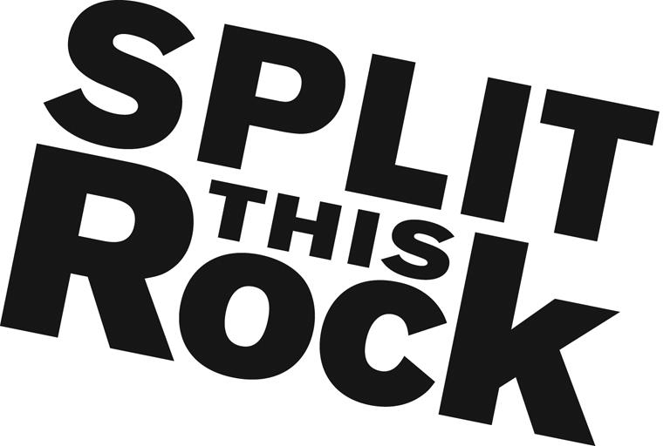

Graphic Design Internship

Organizational Summary
Split This Rock is a non-profit organization that brings poetry to the center of public life and fosters a national network of socially engaged poets. From our home in the nation's capital we celebrate poetic diversity and the transformative power of the imagination. All of Split This Rock's programs are designed to integrate poetry of provocation and witness into public life and to support the poets who write and perform this critical work.

Our cornerstone program is a biennial national festival celebrating poetry and activism, held in Washington, DC. We also have a robust youth program, organize social justice campaigns, present readings and workshops, and sponsor year-round local and national programming at the intersection of poetry and social change. We’re a small but passionate staff housed at the Institute for Policy Studies, the nation’s oldest progressive think tank, located a few blocks from the White House in downtown DC.

Position Description
This un-paid position (travel stipend potentially available upon request) is an opportunity to apply and expand your graphic design skills and gain valuable professional experience while working at the intersection of arts and social change. We are seeking a talented graphic designer to help develop and design our publications, including newsletters, program brochures, direct mail, web graphics and specific publicity material for event marketing. You will have the opportunity to contribute in significant and meaningful ways to the continued growth of a small mission-driven non-profit organization.

Working with Split This Rock’s staff, specific intern responsibilities include:

- Conceptualizing and creating marketing materials for electronic and print uses including ads, fliers and posters for Split This Rock youth events, program brochures, and fundraising materials
- Assisting with marketing and publicity (including social media)
- Creating updated newsletter templates and designing email blasts
- Designing attractive graphics, images, and other visual elements, and adapting them for Split This Rock’s website and social media outlets

Qualifications
We are looking for interns who are:
- Extremely organized with attention to detail and follow through
- Experienced in design software, including Adobe Illustrator, Photoshop and InDesign. Knowledge of Constant Contact and Dreamweaver helpful but not required.
- Have a portfolio of outstanding work, with examples of student projects
- Excellent writing and communications skills
- Able to manage multiple tasks on self-determined schedule
- Passionate and committed to social change. Interest in poetry a plus.
- Creative, flexible and good-natured

This is an exciting opportunity to work with a growing literary arts organization that is unique in the field, while getting to know the local poetry and arts community. We’re looking for an intern who can commit to working 15-20 hours per week (flexible schedule) for a minimum of 10 weeks (ideally longer).

To apply, please send a resume, cover letter outlining your interest in Split This Rock and why you would be a good fit for this position, and an online portfolio link to Administrative Assistant, Emma Bartley at emma@splitthisrock.org. We are accepting applications on a rolling basis. We look forward to hearing from you!

