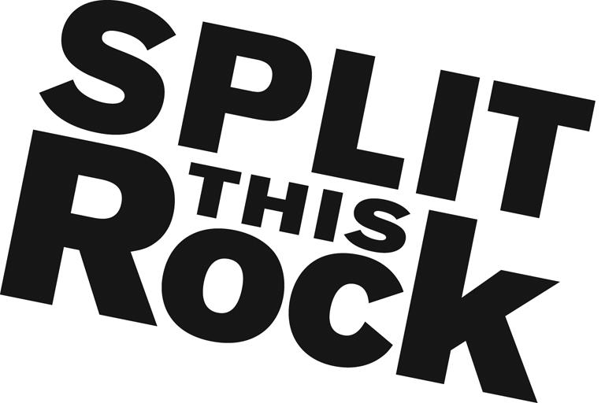

Split This Rock
Eco-Justice Anthology Support Intern (unpaid)
Summer 2016

Organizational Summary
Split This Rock is a non-profit organization that brings poetry to the center of public life and fosters a national network of socially engaged poets. From our home in the nation's capital we celebrate poetic diversity and the transformative power of the imagination. All of Split This Rock's programs are designed to integrate poetry of provocation and witness into public life and to support the poets who write and perform this critical work.

Our cornerstone program is a biennial national festival celebrating poetry and activism, held in Washington, DC. We also have a robust youth program, organize social justice campaigns, present readings and workshops, and sponsor year-round local and national programming at the intersection of poetry and social change. We’re a small but passionate staff housed at the Institute for Policy Studies, the nation’s oldest progressive think tank, located a few blocks from the White House in downtown DC.

Position Description
The Eco-Justice Anthology Support Intern will assist with the compilation of an anthology of poems at the intersection of social justice and the environment, that recognize our human impact on the natural world, and the political and cultural dimensions of our relationship to the environment. The intern will assist with research, data management, outreach to poets and publishers for permissions to publish, and social media strategies. More information on the anthology is available on Split This Rock’s website.

Qualifications
We are looking for interns with the following qualifications:
- Have excellent research and writing/communication skills
- Extremely organized with attention to detail and follow through
- Passionate and committed to social change
- Have some knowledge and love of poetry
- Able to manage multiple tasks on self-determined schedule
- Flexible and good-natured
- Comfortable in cross-cultural settings
- Solid computer and database skills including familiarity with Microsoft Office Suite
- College or graduate students, or recent grads

This is an exciting opportunity to work with a growing literary arts organization that is unique in the field. We’re looking for an intern who can commit to working 10-15 hours per week (flexible schedule) for a minimum of 3-4 months (ideally longer).

To apply, please send a resume, a thoughtful cover letter outlining your interest in Split This Rock and why you would be a good fit for this position, and a brief prose writing sample (no more than two pages - no poetry please) to Tiana Trutna at tiana@splitthisrock.org. We are accepting applications on a rolling basis. We look forward to hearing from you!

