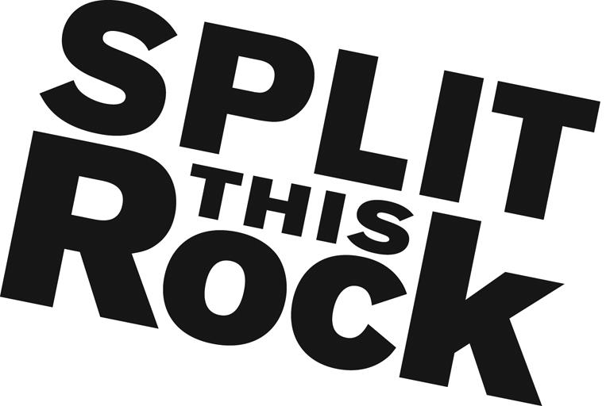

Communications and Social Media Internship

Organizational Summary
Split This Rock is a non-profit organization that brings poetry to the center of public life and fosters a national network of socially engaged poets. From our home in the nation's capital we celebrate poetic diversity and the transformative power of the imagination. All of Split This Rock's programs are designed to integrate poetry of provocation and witness into public life and to support the poets who write and perform this critical work.

Our cornerstone program is a biennial national festival celebrating poetry and activism, held in Washington, DC. We also have a robust youth program, organize social justice campaigns, present readings and workshops, and sponsor year-round local and national programming at the intersection of poetry and social change. We’re a small but passionate staff housed at the Institute for Policy Studies, the nation’s oldest progressive think tank, located a few blocks from the White House in downtown DC.

Position Description
This un-paid position (travel stipend potentially available upon request) combines opportunities to apply and expand your skills in communications, marketing, strategic planning, social media strategy, and non-profit development. You will have the opportunity to contribute in significant and meaningful ways to the continued growth of a small mission-driven non-profit organization.

The Communications and Social Media Intern will play a central role in planning, coordinating and implementing publicity for Split This Rock programs. The intern will also be actively involved in disseminating information about Split This Rock programs via our website, social media, e-mailed marketing campaigns, flyers, posts to online event calendars and other methods of publicity.

Working with Split This Rock’s staff, specific intern responsibilities include:
- Coordinating a social media strategy for Split This Rock events
- Coordinating marketing strategies for Split This Rock events
- Effectively leveraging our social media platforms (Facebook, Twitter, blog and YouTube) to generate increased visibility for Split This Rock and the organization’s work
- Assisting with marketing and publicity for various events and actions, including Sunday Kind of Love (our monthly open mic & poetry reading series), our bi-monthly writing workshops, Split This Rock’s 2016 Poetry Festival and special one-time events
- Maintaining our website so information about upcoming Split This Rock events and news about/by Split This Rock is kept up-to-date
- Ensuring that people who sign up for our mailing lists are added to the lists in a timely manner
- Assisting with other office tasks as needed -- filing, office organization, research, and the day-to-day duties of running a small nonprofit

Qualifications
We are looking for interns with these qualifications:
- Extremely organized with attention to detail and follow through
- Excellent writing and communications skills
- Demonstrated experience and skill on various social media platforms
- Passionate and committed to social change
- Have some knowledge and love of poetry
- Able to manage multiple tasks on self-determined schedule
- Flexible and good-natured
- Comfortable in cross-cultural settings
- Previous communications and/or marketing experience a plus
- College or graduate students, or recent grads preferred

This is an exciting opportunity to work with a growing literary arts organization that is unique in the field, while getting to know the local poetry and arts community. We’re looking for an intern who can commit to working 15-20 hours per week (flexible schedule) for a minimum of 3-4 months (ideally longer).

To apply, please send a resume, a thoughtful cover letter outlining your interest in Split This Rock and why you would be a good fit for this position, and a brief prose writing sample (no more than two pages) to Emma Bartley at emma@splitthisrock.org. We are accepting applications on a rolling basis. We look forward to hearing from you!

