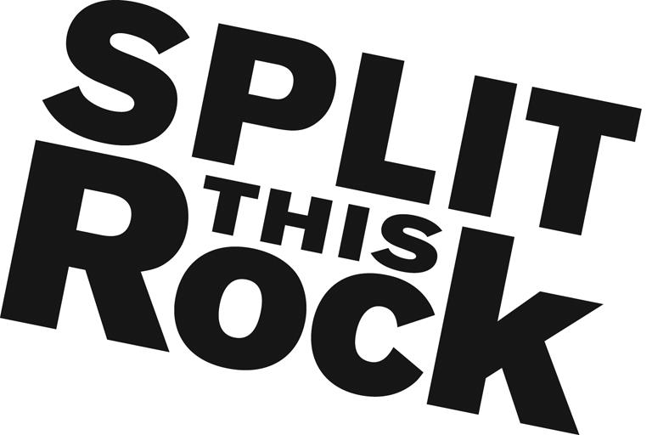

Split This Rock 2018 Festival – Volunteer Manager

Organizational Summary
Split This Rock is a non-profit organization that brings poetry to the center of public life and fosters a national network of socially engaged poets. From our home in the nation's capital we celebrate poetic diversity and the transformative power of the imagination. All of Split This Rock's programs are designed to integrate poetry of provocation and witness into public life and to support the poets who write and perform this critical work.
Our cornerstone program is a biennial national festival celebrating poetry and activism, held in Washington, DC. Split This Rock Poetry Festival: Poems of Provocation & Witness 2018 will take place April 19-21, 2018 and celebrate Split This Rock’s 10th anniversary. Over the course of the three days writers and activists from all over the country gather to participate in panels, workshops, and group readings. The end of each day brings featured readings by some of the country’s most essential voices, including Elizabeth Acevedo, Kazim Ali, Kwame Dawes, Sonia Sanchez, Solmaz Sharif, Terisa Siagatonu, and more to be announced!
We also sponsor a robust youth program, an online social justice poetry database, social justice campaigns, readings, workshops, and year-round local and national programming at the intersection of poetry and social change. We’re a small but passionate staff housed at the Institute for Policy Studies, the nation’s oldest progressive think tank.

Position Description
This unpaid position combines opportunities to apply and expand your skills in event planning and volunteer management. You will have the opportunity to contribute in significant and meaningful ways to the continued growth of a small mission-driven non-profit organization and its cornerstone program.
The 2018 Festival Volunteer Manager will provide leadership for the recruitment, orientation, and coordination of festival volunteers for the 2018 festival (April 19-21, 2018). The festival brings together hundreds of poets, writers, and activists from around the country to Washington, DC for three days of poetry, community building, and creative transformation.
Working in collaboration with Split This Rock festival staff, the Volunteer Manager will have responsibility for:
- Setting up and coordinating volunteer intake process
- Reviewing applications from potential volunteers and following up with each applicant
- Overseeing communication with volunteers, ensuring they have all necessary information, answering their questions, and assisting them with any special situations
- Placement and scheduling of each volunteer
- Overseeing design and implementation of volunteer orientation meetings
- Design and dissemination of evaluation for festival volunteers
- Providing ways to thank volunteers
Additionally, the intern(s) will assist with other office tasks as needed--filing, office organization, research, and the day-to-day duties of running a small nonprofit.

Qualifications
We are looking for interns who are:
- Extremely organized with attention to detail and follow through
- Excellent writing and communications skills
- Comfortable juggling various moving pieces of a major festival
- Passionate and committed to social change
- Have some knowledge and love of poetry
- Able to manage multiple tasks on self-determined schedule
- Flexible and good-natured
- Comfortable in cross-cultural settings
- Solid computer skills, including Microsoft Office Suite
- College or graduate students, or recent grads
This is an exciting opportunity to work with a growing literary arts organization that is unique in the field, while getting to know the local poetry and arts community. We’re looking for an intern who can commit to working 10-15 hours per week (flexible schedule) for a minimum of 6-8 months (ideally longer).
To apply, please send a resume, a thoughtful cover letter outlining your interest in Split This Rock and why you would be a good fit for this position, and a brief prose writing sample (no more than two pages) to poetryfest@splitthisrock.org. We are accepting applications on a rolling basis. We look forward to hearing from you!

