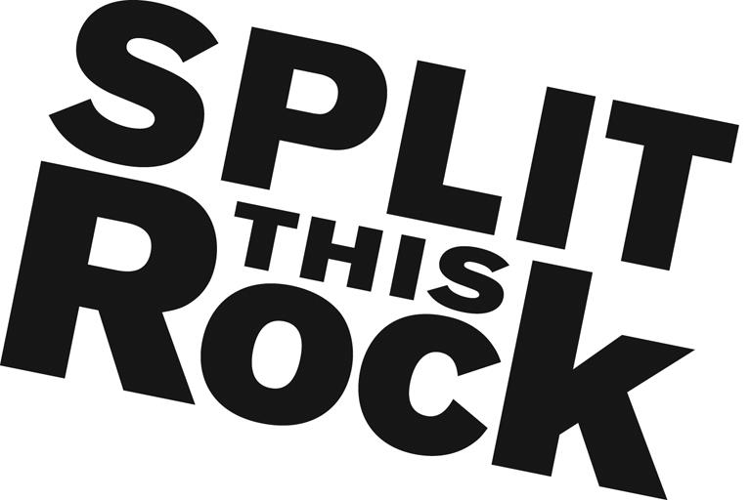

Split This Rock 2018 Poetry Festival Fellow

(Part-Time, Temporary Paid Internship)

Organizational Summary
Split This Rock is a non-profit organization that brings poetry to the center of public life and fosters a national network of socially engaged poets. Founded in 2008, Split This Rock cultivates, teaches, and celebrates poetry that bears witness to injustice and provokes social change. From our home in the nation's capital we celebrate poetic diversity and the transformative power of the imagination. All of Split This Rock's programs are designed to integrate poetry of provocation and witness into public life and to support the poets who write and perform this critical work.
Our cornerstone program is a biennial national festival celebrating poetry and activism, held in Washington, DC. The next festival, our sixth, will take place April 19-21, 2018, coinciding with the 10th anniversary of Split This Rock. Over the course of the three days writers and activists from all over the country will gather to participate in panel discussions, workshops, and group readings. Each night brings featured readings by some of the country’s most essential voices. Featuring at the 2018 festival thus far, with more to come, are Elizabeth Acevedo, Kwame Dawes, Solmaz Sharif, and Sonia Sanchez.
We also sponsor a robust youth program, an online social justice poetry database, social justice campaigns, readings, workshops, and year-round local and national programming at the intersection of poetry and social change. We’re a small but passionate staff housed at the Institute for Policy Studies, the nation’s oldest progressive think tank.

Position Description
This short-term paid position provides an opportunity to apply and expand your skills in the areas of event planning, volunteer management, communications, marketing, strategic planning, fundraising, and non-profit work. This is an opportunity to build skill and contribute in significant ways to the work of a dynamic literary arts organization that is unique in its field as it approaches the milestone of its 10th anniversary.
The 2018 Poetry Festival Fellow will play a central role in planning, coordinating, and implementing Split This Rock Poetry Festival: Poems of Provocation & Witness 2018. Specific responsibilities of this position include working with Split This Rock staff, interns, and volunteers to:
- Recruit, manage, coordinate, orient, and aid in supervising festival volunteers
- Oversee communications with festival session leaders and assist with session management
- Assist in working with venues in preparation for the festival
- Help to organize festival’s call to action, open mics, party, and book fair
- Handle festival mobile app prep work
- Assist with efforts to include 10th anniversary celebration elements in the festival
- Support the festival registration process
- Assist with festival marketing efforts and outreach efforts
- Support sponsorship and fundraising efforts
- Work collaboratively with festival lead interns, volunteers, and the festival planning committee
- Provide logistical support in the lead up to the festival
- Support other Split This Rock efforts as time allows

Qualifications
We are looking for candidates who are:
- Extremely well organized with attention to detail and follow through
- Experienced in event and volunteer coordination
- Excellent at writing, editing, and communications
- Comfortable juggling multiple time-sensitive tasks
- Passionate about and committed to social change
- Able to manage several projects on self-determined schedule
- Flexible and good-natured
- Comfortable in cross-cultural settings
- Solid social media and computer skills, including Microsoft Office Suite
Candidates should also have a knowledge and love of poetry. Candidates with at least 2 years of event planning, volunteer coordination, and outreach experience preferred.
Position Hours & Stipend
This is a 9-month position, October or November 2017 through April 2018. It comes with a monthly stipend of $500, with an additional $500 each month in March and April. Responsibilities require a commitment of approximately 10-15 hours per week with a flexible schedule. Additional hours required in the final weeks leading up to Split This Rock Poetry Festival: Poems of Provocation & Witness (April 19-21) and selected candidate would be needed on-site at the festival each day.

How to Apply
Please send a resume, a list of 3 references, a thoughtful cover letter outlining your interest in Split This Rock and why you would be a good fit for this position, and a brief 1-2 page prose writing sample (no poetry please) via email with the subject “2018 Poetry Festival Fellow” to Camisha Jones at info@splitthisrock.org by 10 am on Monday, October 30. We look forward to hearing from you!
People of color, LGBTQ+ people, women, and people with disabilities are encouraged to apply.

