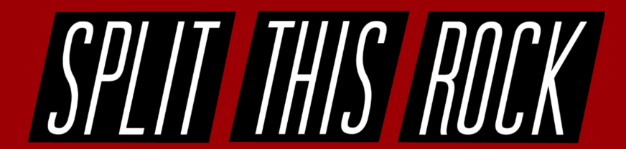

POETRY FESTIVAL: POEMS OF PROVOCATION & WITNESS 2018
April 19-21, 2018 | Washington, DC

CELEBRATING SPLIT THIS ROCK’S 10TH ANNIVERSARY

volunteer registration form
As a small but mighty non-profit organization, Split This Rock depends heavily on the support of talented volunteers and interns. While we seek people who have a passion for poetry and social activism, we also need people with a broad range of skills. In other words: You don't have to be a poet or writer to volunteer!
Folks who serve in festival leadership roles or who volunteer 5 or more hours in the week(s) prior to and/or during the festival get the fabulous reward of a FREE registration for the entire festival. (Information on leadership roles is available at Split This Rock's website.
There is a tremendous amount of work necessary to make the 2018 Poetry Festival happen and we couldn't do it without your volunteer support. So THANK YOU!
If you have any questions on intern or volunteer roles, please email us at poetryfest@splitthisrock.org or call 202-787-5210.

Please Supply the Following Contact Information:
First and Last Name:
Preferred Pronouns:
Email Address:
Cell Phone:
Alternate Phone Number:
Home Mailing Address (include street address, city, state, and zip code):

Volunteering Prior to the Festival
In the week or two immediately prior to the festival, we'll need LOTS of help with hands-on tasks, such as organizing materials, making copies, preparing for volunteer orientation, preparing name tags for all attendees, etc. Periodically, these kinds of tasks may also be needed in the months prior to the fest. Volunteers who are able to work at our office are especially helpful to us. Our offices are located at 1301 Connecticut Ave. NW, Washington, DC (one block south of Dupont Circle Metro, South Exit).
Additionally, we need assistance with longer term projects. If you're interested in volunteering 10-15 hours a week with those things, please consider one of our festival leadership positions. Details on those positions are available at our website.
Please answer the following questions:
- Are you available to help at our office prior to the festival?
- About how many hours would you be interesting in volunteering for the festival between April 2 and April 18, 2018? (We will be in touch with you closer to the festival to schedule specific times for you to come in.)
- Is there a type of work you would prefer not to do?

Volunteer Roles During the Festival (April 19-21)
We're looking for friendly and reliable folks to fill many important roles. Please let us know below what roles you are most interested in during the festival, as well as other ways you'd like to contribute that may not be listed (photography, videotaping, live-tweeting, etc.).

Please list here ways you’d like to contribute (from the list below or other ideas you have):

REGISTRATION HELPERS
Provide hospitality while assisting with festival attendee registration, distributing fest materials (program books, name tags, etc), and answering questions.

PRESS TABLE ASSISTANTS
Greet members of the press, provide them with press packages, and answer questions.

VENUE GREETERS
Be a friendly face at venues, helping attendees navigate spaces where daytime sessions are held, including guiding people to accessibility entrances & accommodations.
MERCHANDISE TABLE STAFF
Help to organize, sell, pack, and transport Split This Rock and festival merchandise.

FEATURED READING USHERS
Welcome attendees to featured poet readings, hand out programs, and help people find seating.

OFFSITE EVENT HELPERS
Assist with set up and coordination of open mics and Saturday night's party. Photographers also needed! These events begin at 10 pm and run late.
PUBLIC ACTION ASSISTANTS
Help to set up and implement the public action, the festival's call to action.
BOOK FAIR HELPERS (Saturday Only)
Assist with set up and clean up, help exhibitors as they arrive or have questions, greet book fair attendees, answer questions.

FLOATERS
Help with various time-sensitive needs as they arise.

ASL INTERPRETERS
Share your skill as an interpreter to help us make the festival as accessible as possible.

ON-CALL COUNSELORS
If you are trained mental health counselor, let us know if we can call upon you!

Anything else you’d like us to know? Please tell us below.

