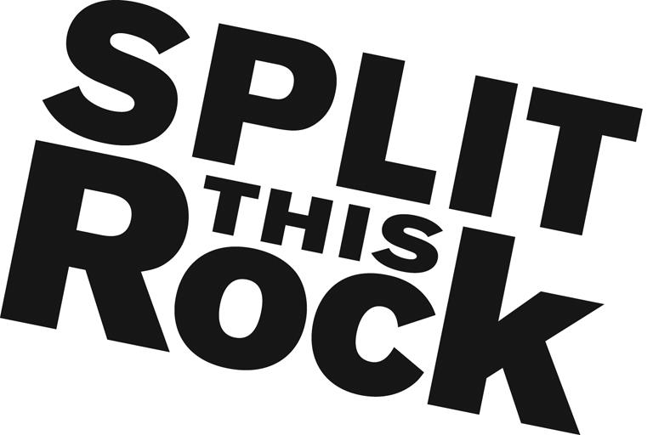

Split This Rock 2016 Festival – Special Events Manager

Organizational Summary
Split This Rock is a non-profit organization that brings poetry to the center of public life and fosters a national network of socially engaged poets. From our home in the nation's capital we celebrate poetic diversity and the transformative power of the imagination. All of Split This Rock's programs are designed to integrate poetry of provocation and witness into public life and to support the poets who write and perform this critical work.

Our cornerstone program is a biennial national festival celebrating poetry and activism, held in Washington, DC. The next festival, our fifth, will take place April 14-17, 2016. Over the course of the four days writers and activists from all over the country gather to participate in panels, workshops, and group readings. Each night brings featured readings by some of the country’s most essential voices. Featuring at the 2016 festival are: Jan Beatty, Reginald Dwayne Betts, Dominique Christina, Nikky Finney, Ross Gay, Juan Felipe Herrera, Linda Hogan, Craig Santos Perez, Ocean Vuong, and more.
We also have a robust youth program, organize social justice campaigns, present readings and workshops, and sponsor year-round local and national programming at the intersection of poetry and social change. We’re a small but passionate staff housed at the Institute for Policy Studies, the nation’s oldest progressive think tank, located a few blocks from the White House in downtown DC.

Position Description
This unpaid position combines opportunities to apply and expand your skills in event planning. You will have the opportunity to contribute in significant and meaningful ways to the continued growth of a small mission-driven non-profit organization and its cornerstone program.
The 2016 Festival Special Events Manager supports efforts to secure festival sponsorships for Split This Rock’s upcoming biennial national poetry festival (April 14-17, 2016). The festival brings together hundreds of poets, writers, and activists from around the country to Washington, DC for four days of poetry, community building, and creative transformation.
Working with Split This Rock’s staff, specific responsibilities include:
- Determining issue for focus of the festival's public action
- Securing venue for public action and serving as point of contact for that venue
- Coordinating volunteers and materials for public action
- Planning for public action, open mics, social, etc
- Overseeing outreach for public action
- Organizing logistics and volunteers for each special event
Additionally, the intern(s) will:
- Assist with other office tasks as needed--filing, office organization, research, and the day-to-day duties of running a small nonprofit

Qualifications
We are looking for interns who are:
- Extremely organized with attention to detail and follow through
- Excellent writing and communications skills
- Comfortable juggling various moving pieces of a major festival
- Passionate and committed to social change
- Have some knowledge and love of poetry
- Able to manage multiple tasks on self-determined schedule
- Flexible and good-natured
- Comfortable in cross-cultural settings
- Previous communications and/or marketing experience a plus
- College or graduate students, or recent grads

This is an exciting opportunity to work with a growing literary arts organization that is unique in the field, while getting to know the local poetry and arts community. We’re looking for an intern who can commit to working 10-15 hours per week (flexible schedule) for a minimum of 6-8 months (ideally longer).

To apply, please send a resume, a thoughtful cover letter outlining your interest in Split This Rock and why you would be a good fit for this position, and a brief prose writing sample (no more than two pages) to Tiana Trutna at tiana@splitthisrock.org. We are accepting applications on a rolling basis. We look forward to hearing from you!

